


ASSIGNMENT TOP SHEET
Faculty of Creative Arts, Technologies & Science
Department of Computing & Information Systems

Student Number: 1822753 | Unit Code : PAT001-2 (Assignment 1)

Unit Name  Object-Oriented Programming and Software Engineering |  | Deadline for Submission(s)  10:00AM 13th Nov 2020 (TBC)

Student's Surname  Kathayat |  | Student's Forename  Kapendra

Assignment Details: Assignment 1: Control an Elevator - A C# Project

Contents
1.Introduction 2
2.Statement of Problem 2
3.Aim and Objective 3
4.Software Development Method 3
4.1.Activity Diagram 3
4.2.Class Diagram 4
5.Hardware and Software Requirement 4
5.1.Hardware 4
5.2.Software: 5
6.Backup and Recovery 5
7.Design 6
8.Program 7
9.Testing 12
10.Conclusion 15

1.Introduction
Elevator control is a desktop application project given by the university of the Bedfordshire. This project is the simulation of the only two floor building office where user of the elevator can request for the elevator from first and ground floor. Control elevator can also have a control panel inside the elevator where user can open/closed the door from inside the elevator. The user of the elevator can also saw either the elevator goes up or down through display screen inside the elevator.

2.Statement of Problem
At the beginning of this project the whole project/assignment brief is studied from the University and then discussed with teacher as well as researched the whole assignment. Researched has been done and some similar type of assignment were found from git-hub and other source but they were done from java and database were done from mySQL. Some of the interfaced and design is quite impressive so those features will be added in this assignment.

3.Aim and Objective
The aim of this project was to enhance our programming capabilities in C sharp. This would help in solving real world problems.

For the software development it is necessary to have a clear objective of that project and problem analysis is already done so that it will be easy for developer to work on a given project. Here are the list of the main objective of the control elevator.
- Simulation of two floor.
- Two request buttons on each floor.
- Control panel for the user inside the elevator.

4.Software Development Method
For the control elevator project as given by the university I used object-oriented programming as per requirement given by the university. So, I implement object-oriented concept.

4.1.Activity Diagram
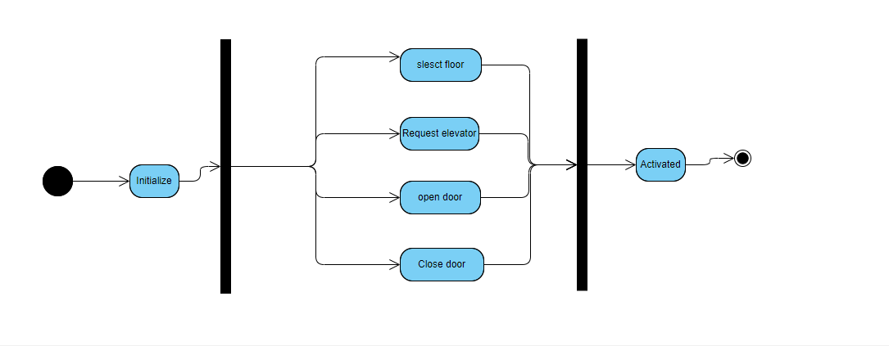
Figure 1. Figure showing Activity Diagram

4.2.Class Diagram
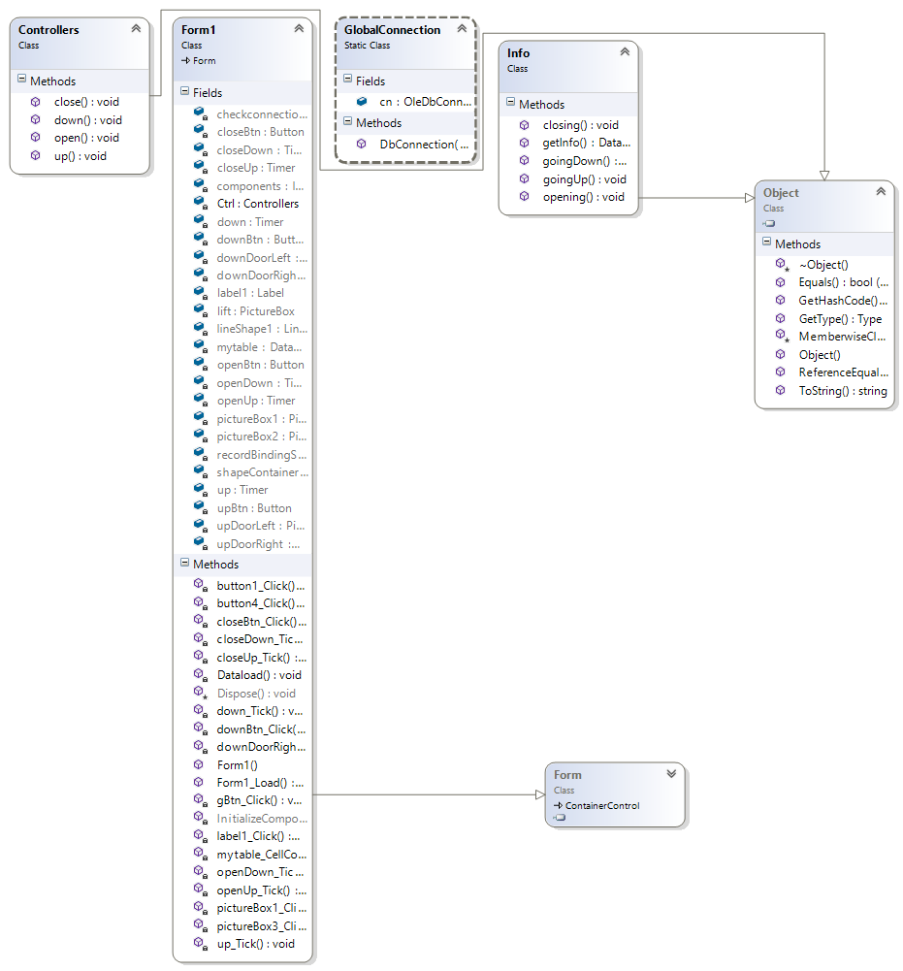
Figure 2. Figure showing Class Diagram

5.Hardware and Software Requirement

5.1.Hardware
- Processor: Intel® Core™ i7-6200U CPU @2.30Hz 2.40GHz
- RAM: 16.00 GB
- 2 TB HDD
- Keyboard and Mouse
- Intel Motherboard

5.2.Software:
- Operating system: Microsoft Window 10, 8 or 7
- Languages used: C#.
- IDE: Microsoft Visual Studio.net/.net framework.
- Database: MS Access.

6.Backup and Recovery
Data loss and data crashing is one of the main problem which are mostly faced by the software developer for the data recovery. It is really important to use backup and recovery system. So for the backup of the project I used GitHub so in case my system get crash or I lost my laptop that I can easily recover all the project that’s why I used MS Access for the database.

7.Design

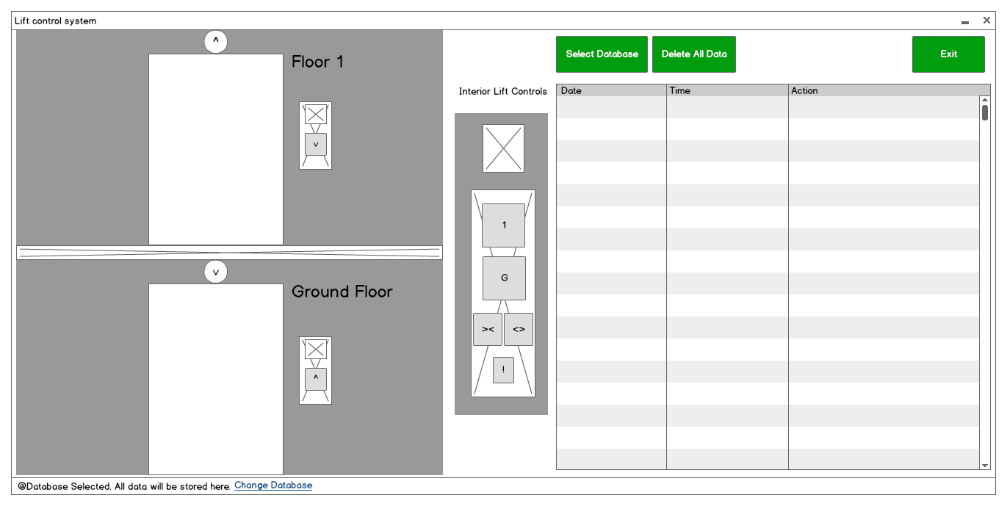
The project started with a concept design as shown below :
Fig3.Inital stage of Assignment

The graphical user interface design was kept simple. Although during the actual programming some components were omitted or changed.

8.Program

The program is broken down and explained as follows:

Form1.cs

using System;
using System.Collections.Generic;
using System.ComponentModel;
using System.Data;
using System.Drawing;
using System.Linq;
using System.Text;
using System.Threading.Tasks;
using System.Windows.Forms;
using System.Speech;
using System.Speech.Synthesis;
using System.Data.OleDb;

The above code adds all the references to the libraries used in the program.

using System.Speech;
using System.Speech.Synthesis;
This code is used to use the library that enables us to us text to speech functions and add voice to our program.

using System.Data.OleDb;
This code is used to connect the program to a database.

//variables

int y_up = 63;
int y_down = 376;
int x_door_left_close = 74;
int x_door_left_open = 12;
int x_door_right_close = 139;
int x_door_right_open = 200;

bool go_up = false;
bool go_down = false;

bool arrived_G = false;
bool arrived_1 = false;

//Database Variables and instantiations
private bool filled;
public DataSet ds = new DataSet();

//object
SpeechSynthesizer reader = new SpeechSynthesizer();

This part of the code instantiates all the variables and objects used in the program.

public Form1()
{
InitializeComponent();
}
This function calls the initializeComponent(); function that builds up the whole user interface.

private void timer_lift_down_Tick(object sender, EventArgs e) //Moves the lift Down
{

if (picture_lift.Top <= y_down)
{
picture_lift.Top += 1;
}
else
{
timer_lift_down.Enabled = false;
btn_up.Enabled = true;
btn_1.Enabled = true;
btn_close.Enabled = true;
btn_open.Enabled = true;
btn_down.BackColor = Color.White;
btn_G.BackColor = Color.White;

door_open_down();
arrived_G = true;

picture_lift.Image = global::ElevatorControl.Properties.Resources.Inside_of_the_lift;

display_panel.Image = global::ElevatorControl.Properties.Resources.G;
display_top.Image = global::ElevatorControl.Properties.Resources.G;
display_bottom.Image = global::ElevatorControl.Properties.Resources.G;
}
}
This function is called every time the timer interval runs out and moves the lift down. At every interval an if statement check if the current location of the picture box has reached its final location and moves it by 1 pixel down. When the picture box reaches its final co ordinates, the timer is disabled and all buttons are enabled again.

The private void timer_lift_up_Tick(object sender, EventArgs e) //Moves the lift Up
Function works in the same way, but moves the lift up.

private void timer_door_open_down_Tick(object sender, EventArgs e) //Opens the Ground floor doors
{
if (door_left_down.Left >= x_door_left_open && door_right_down.Left <= x_door_right_open)
{
door_left_down.Left -= 1;
door_right_down.Left += 1;
}
else
{

timer_door_open_down.Enabled = false;

}
}
This function is called at every interval of the timer_door_open_down and it opens the doors at the ground floor.

private void timer_door_close_down_Tick(object sender, EventArgs e)

private void timer_door_open_up_Tick(object sender, EventArgs e)

private void timer_door_close_up_Tick(object sender, EventArgs e)

private void door_close_down() //Activates the timer for closing Ground floor doors
{
reader.Speak("doors closing");
insertdata("Doors Closing @Ground Floor");
timer_door_close_down.Enabled = true;
timer_door_open_down.Enabled = false;
}
This function enables the timer to close the door for the ground floor. It also calls another function, insertdata("Doors Closing @Ground Floor");
This assigns a string as a function parameter.

private void door_open_down()
private void door_close_up()
private void door_open_up()

The above functions work in the same way.

private void going_up() //Activates the timer for moving the lift up
{
go_up = true;
door_close_down();
btn_G.Enabled = false;
btn_down.Enabled = false;
btn_close.Enabled = false;
btn_open.Enabled = false;
arrived_G = false;
insertdata("Lift Going Up");
}

This function calls the door_close_down() method and disables other buttons

private void going_down()
This function also works in the same manner although it calls the door_close_up() method

private void btn_down_Click(object sender, EventArgs e)
{
btn_up.BackColor = Color.Red;
going_up();

}
This function is an event handler when the button btn_down_click is pressed. It changes the backcolor to red and calls the going_up() method

private void btn_1_Click(object sender, EventArgs e)
is the same.

private void btn_up_Click(object sender, EventArgs e)
private void btn_G_Click(object sender, EventArgs e)

work in the same way but they call going_down() method instead.

private void btn_alarm_Click(object sender, EventArgs e)
{
btn_alarm.BackColor = Color.Green;
reader.Speak("Emergency Stop. Please exit carefully.");
insertdata("Emergency Stop!");
timer_lift_down.Enabled = false;
timer_lift_up.Enabled = false;
timer_door_open_down.Enabled = true;
timer_door_open_up.Enabled = true;
display_panel.Image = global::ElevatorControl.Properties.Resources.alarmbellbutton;
display_top.Image = global::ElevatorControl.Properties.Resources.alarmbellbutton;
display_bottom.Image = global::ElevatorControl.Properties.Resources.alarmbellbutton;

}
This function Stops the lift movement and opens all the doors on both floors. It is an added function not required by the project.

private void btn_displaylog_Click(object sender, EventArgs e)
{
try
{
string dbconnection = "Provider=Microsoft.ACE.OLEDB.12.0;Data Source=ElevatorDatabase.accdb;";
string dbcommand = "Select * from Actions;";
OleDbConnection conn = new OleDbConnection(dbconnection);
OleDbCommand comm = new OleDbCommand(dbcommand, conn);
OleDbDataAdapter adapter = new OleDbDataAdapter(comm);

//cnn.Open();
conn.Open();
//MessageBox.Show("Connection Open ! ");
while (filled == false)
{
adapter.Fill(ds);
filled = true;
}
//cnn.Close();
conn.Close();
}
catch (Exception)
{
MessageBox.Show("Can not open connection ! ");
string message = "Error in connection to datasource";
string caption = "Error";
MessageBoxButtons buttons = MessageBoxButtons.OK;
DialogResult result;
result = MessageBox.Show(message, caption, buttons);
}

database_listbox.Items.Clear();
foreach (DataRow row in ds.Tables[0].Rows)
{
database_listbox.Items.Add(row["Date"] + "\t\t" + row["Time"] + "\t\t" + row["Action"]);
}

}
This function connects to the MS Access database and displays all the data into the database_listbox

private void insertdata(string action)
{
string dbconnection = "Provider=Microsoft.ACE.OLEDB.12.0;" + @"data source = ElevatorDatabase.accdb;";
string dbcommand = "insert into [Actions] ([Date],[Time],[Action]) values (@date, @time, @action)";
string date = DateTime.Now.ToShortDateString();
string time = DateTime.Now.ToLongTimeString();
database_listbox.Items.Add(date + "\t\t" + time + "\t\t" + action);

OleDbConnection conn_db = new OleDbConnection(dbconnection);
OleDbCommand comm_insert = new OleDbCommand(dbcommand, conn_db);
OleDbDataAdapter adapter_insert = new OleDbDataAdapter(comm_insert);
comm_insert.Parameters.AddWithValue("@date", date);
comm_insert.Parameters.AddWithValue("@time", time);
comm_insert.Parameters.AddWithValue("@action", action);
conn_db.Open();

comm_insert.ExecuteNonQuery();

conn_db.Close();
}
This function inserts data into the database and saves it.

The Form1.Designer.cs holds all the code for the User interface generated by the form designer.

9.Testing
The finished program was run with the following operations:
When the program is executed it is displayed as this.

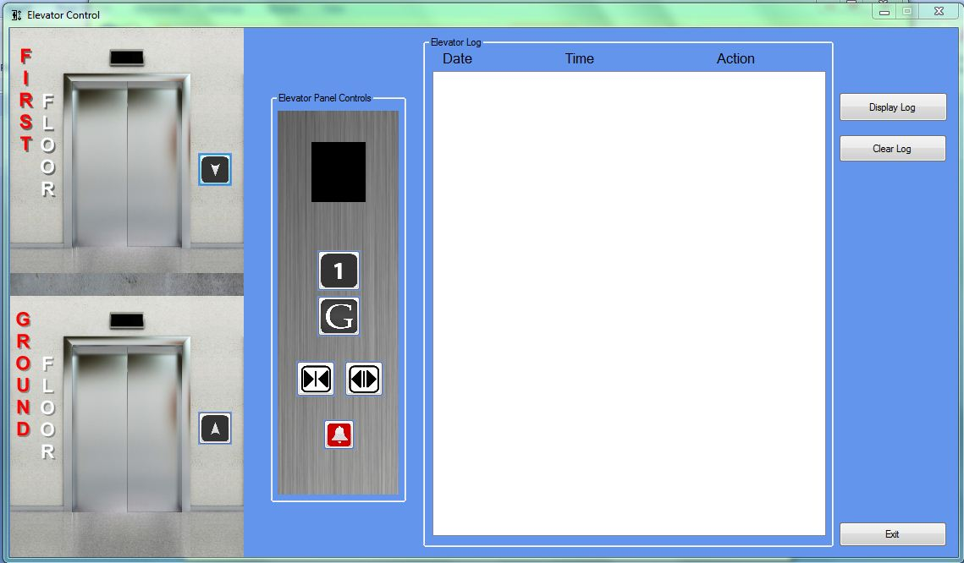
Fig4.First Display
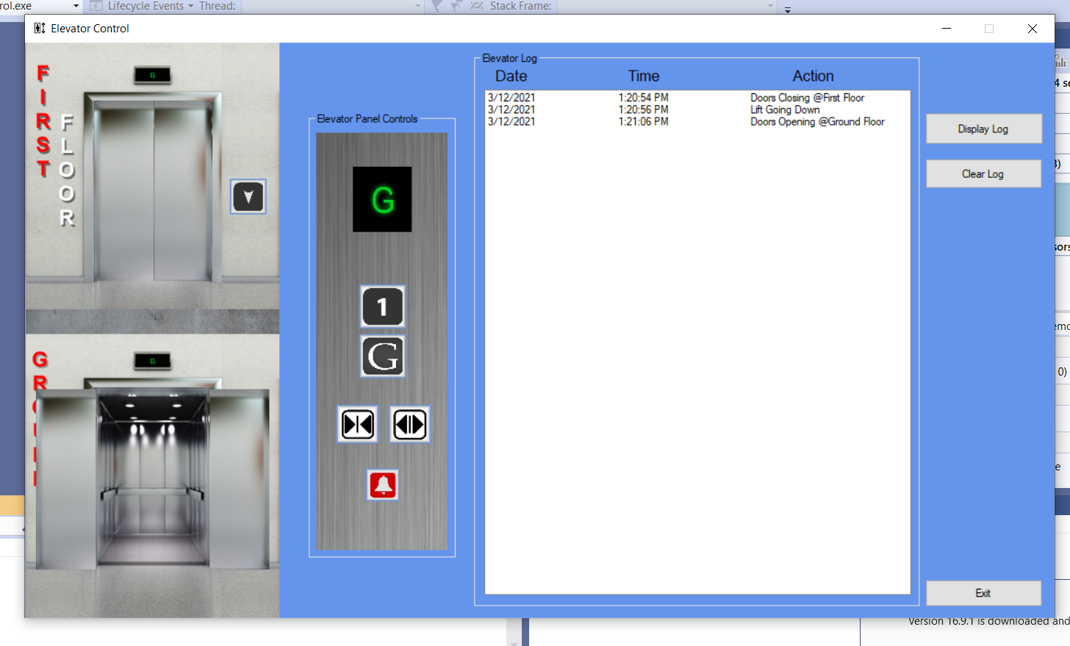

Fig4.first floor
The Ground floor button was pressed from inside the lift on the control panel. The listbox then displayed data that was added to the database.

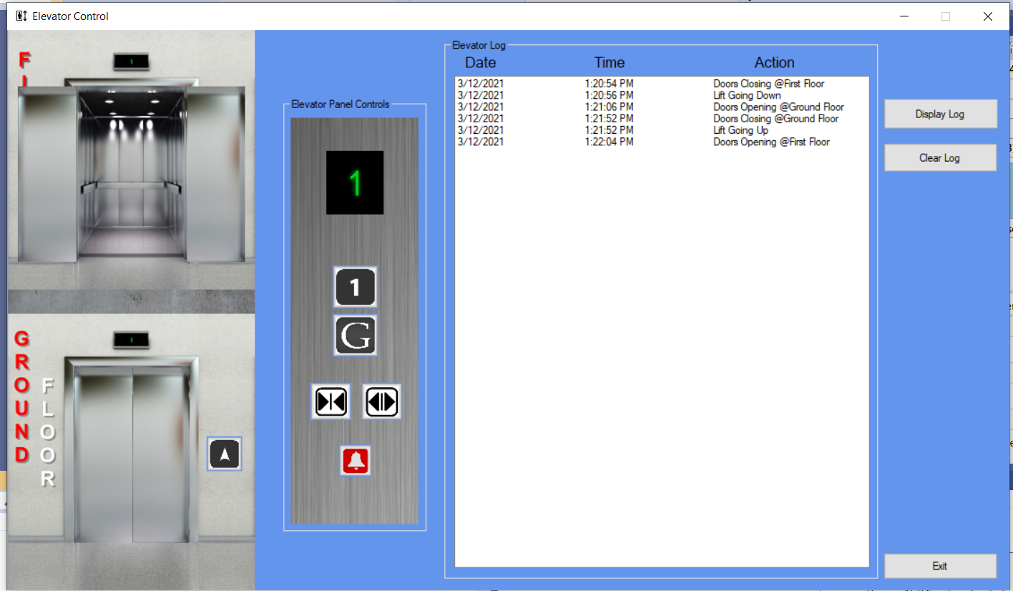
Fig5.ground floor
The first floor button was pressed to go to the first floor. Respective data was collected and stored in the database and viewed in the listbox.

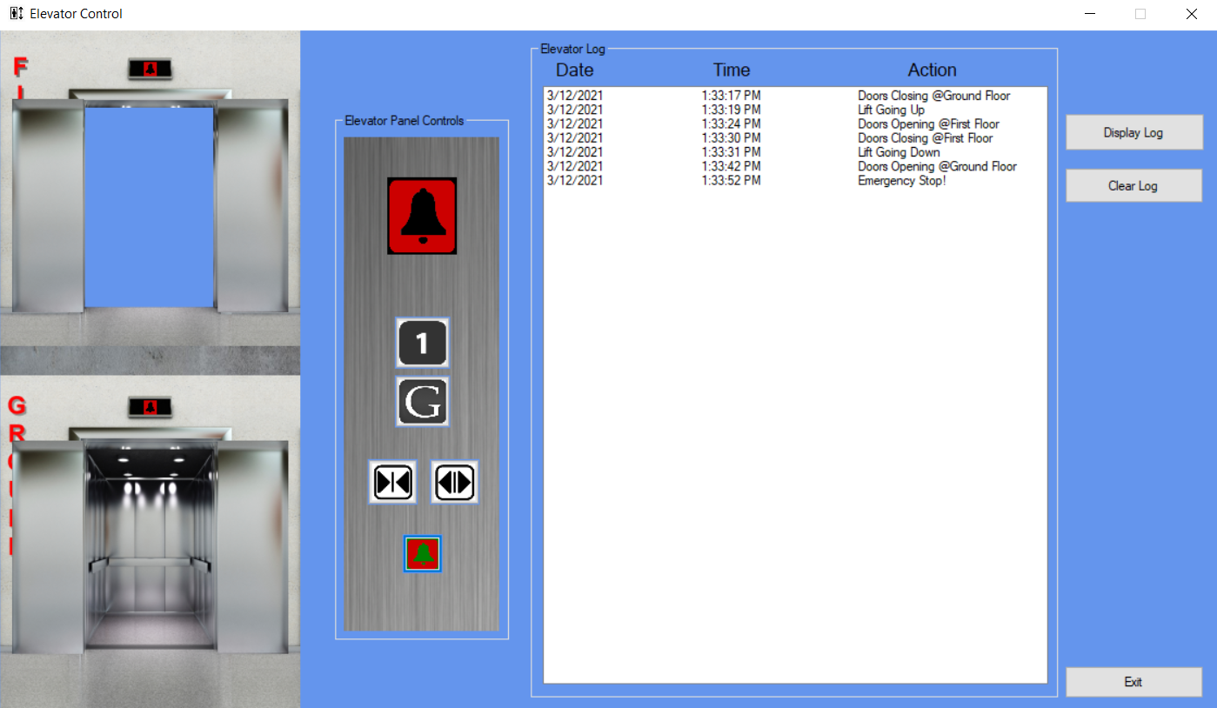
Fig6.Emergancy stop

The emergency button stops the lift movement and opens all the doors. A narrated voice is also accompanied.
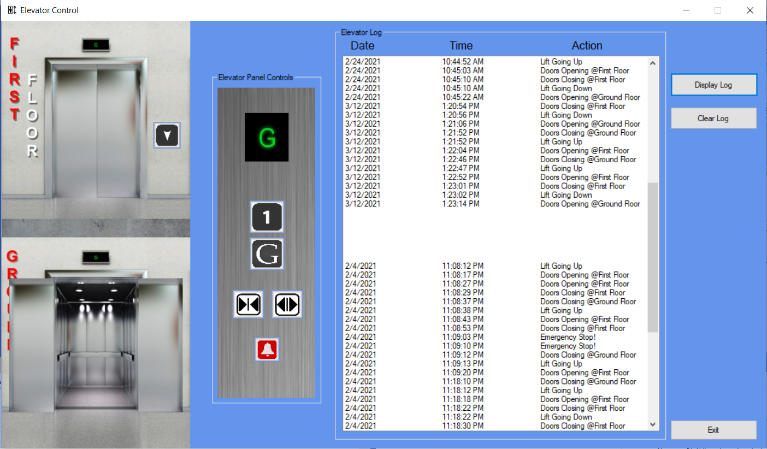
Fig7.Display Log
When the Display Log button is pressed all the data is retrieved and displayed on the

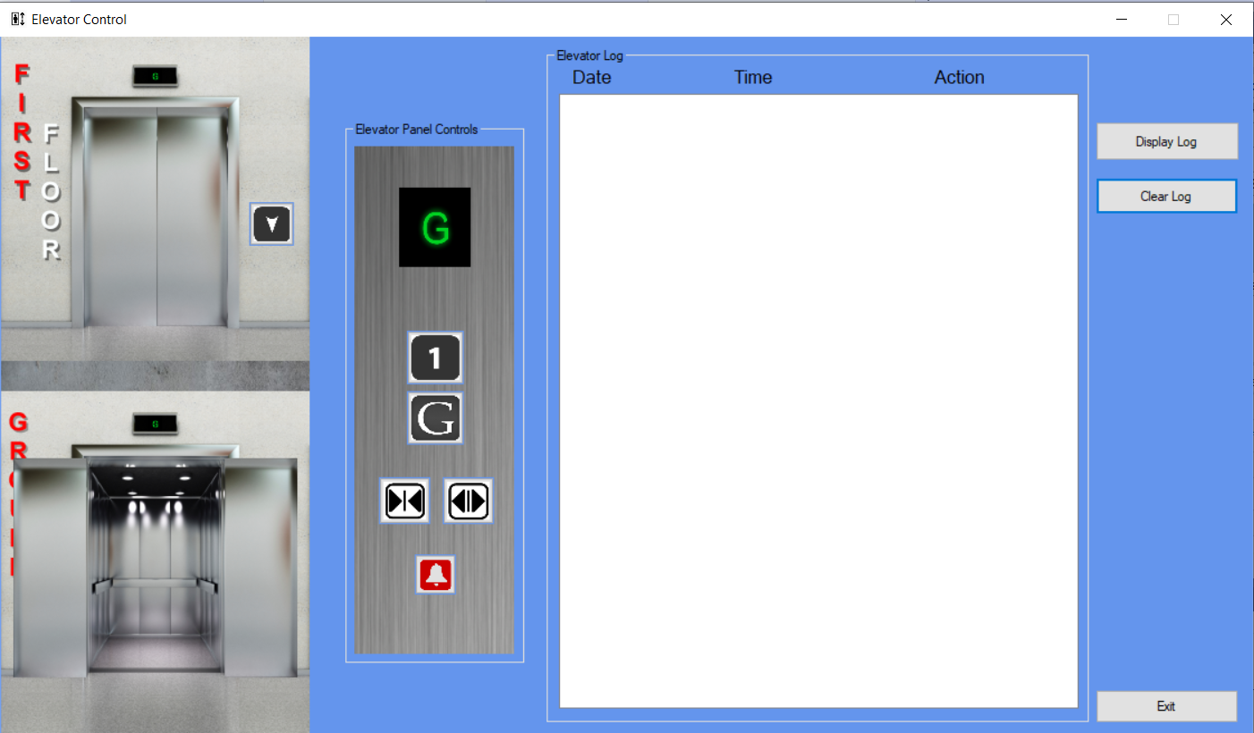

Fig8.Clearlog

When the clear log is pressed then all the recorded log will removed but not from the database.
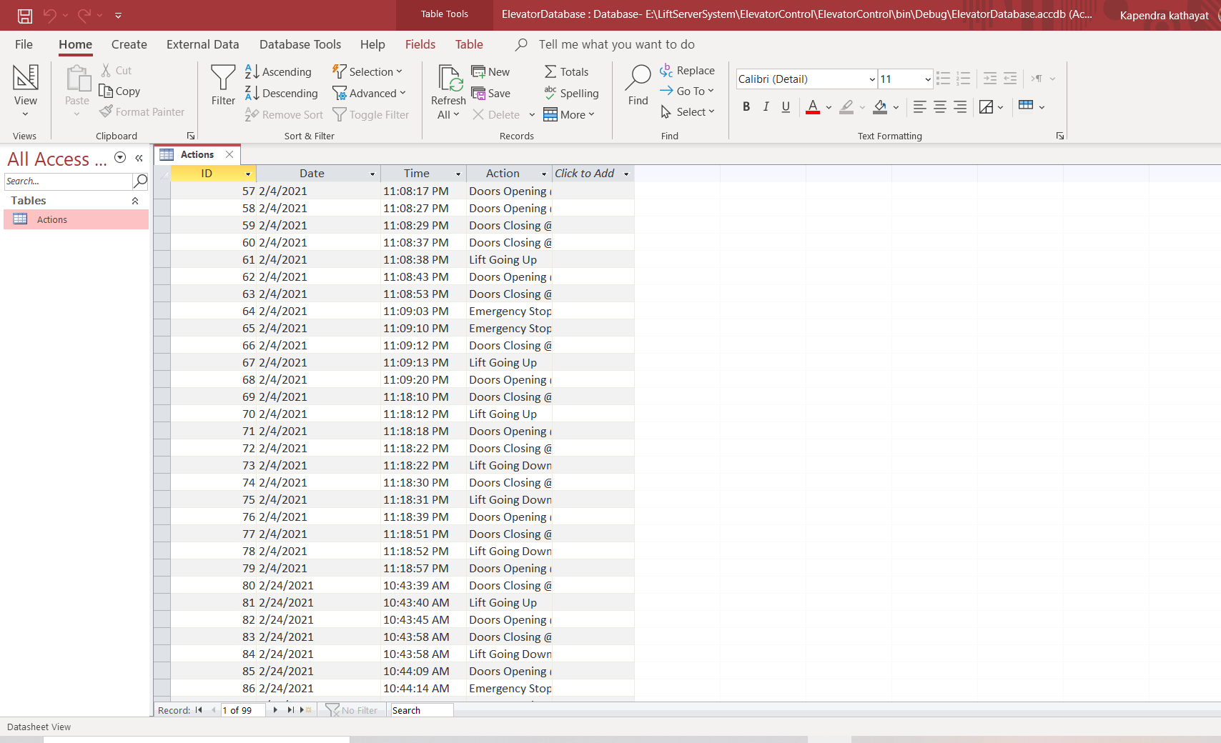

Fig9.Database

It is a Microsoft access database in this database all the recored logs are saved inside this if we like to see the all the recorded logs then in the project folder we can easily access to this database file.

10.Conclusion
During the phase of implementation and testing, whole software was developed upon the proposed design and module have been tested for functional requirement.
After completion of the project I get to know and learned about the C# programming language, I have learn the concept of the object-oriented programming in a real-life project. I have learnt how to connect the database with the MS access and the My SQL.

